
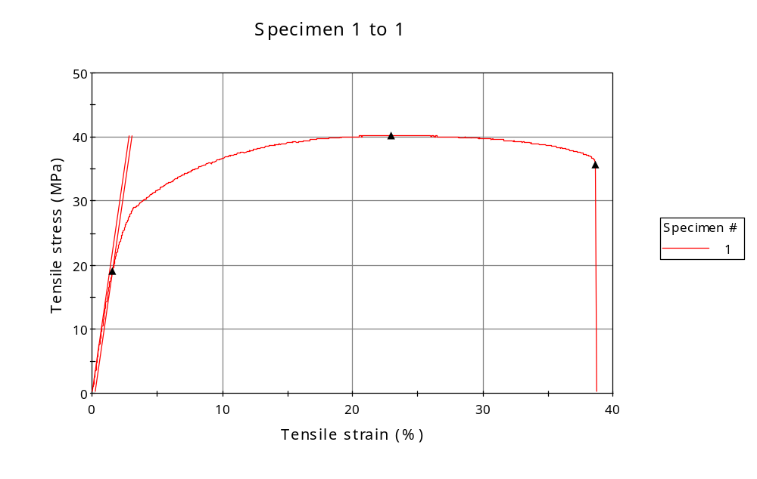
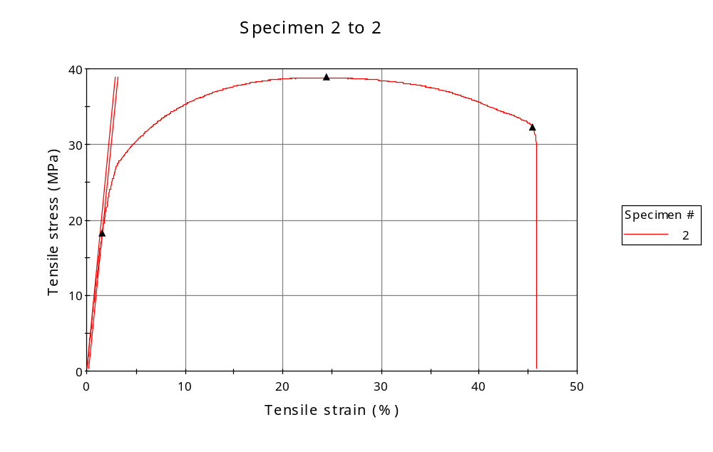
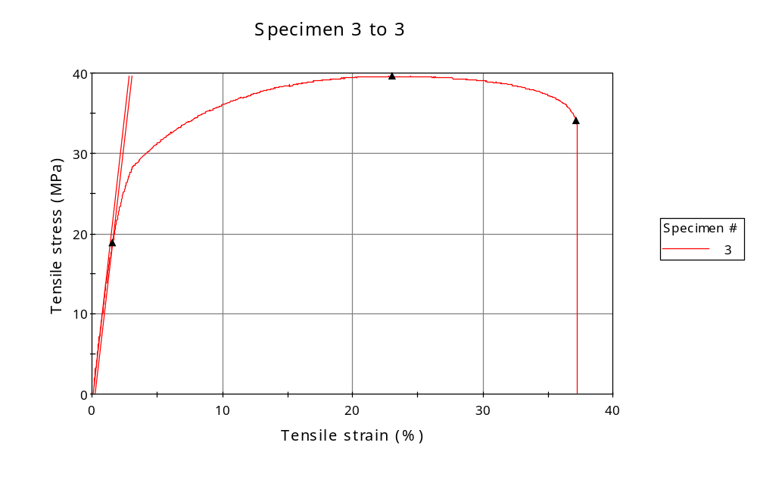
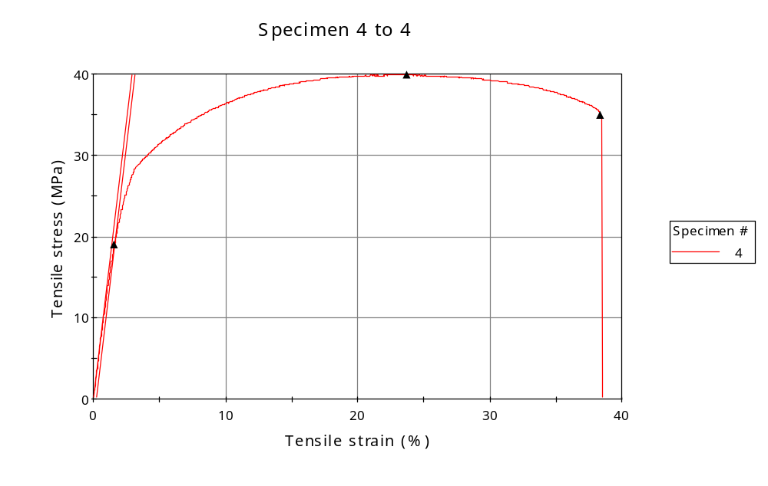
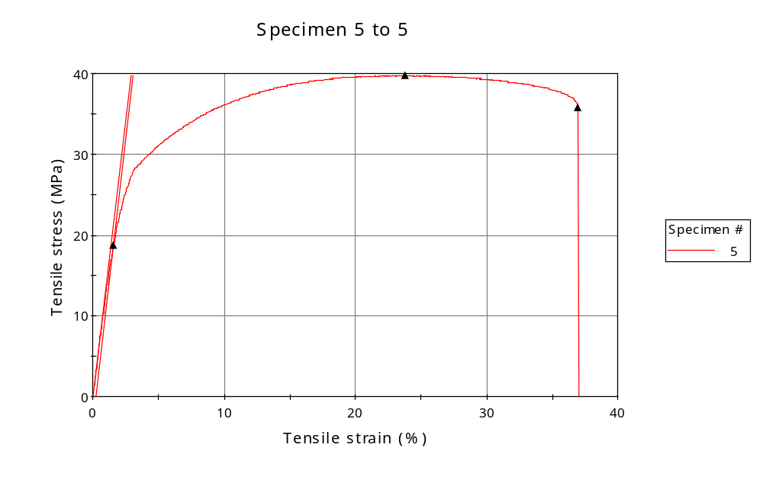
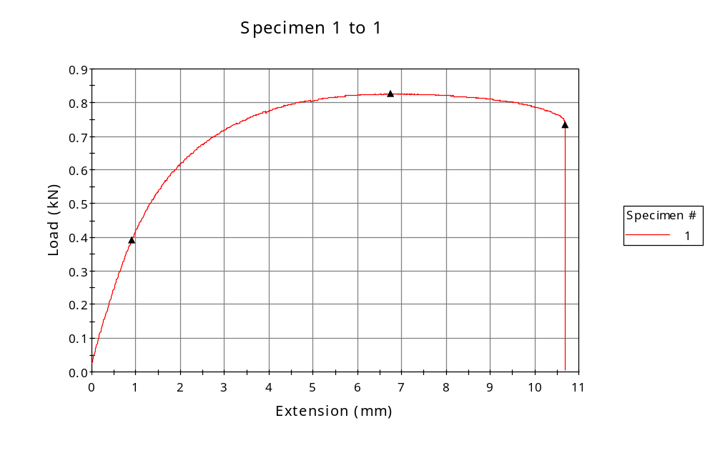
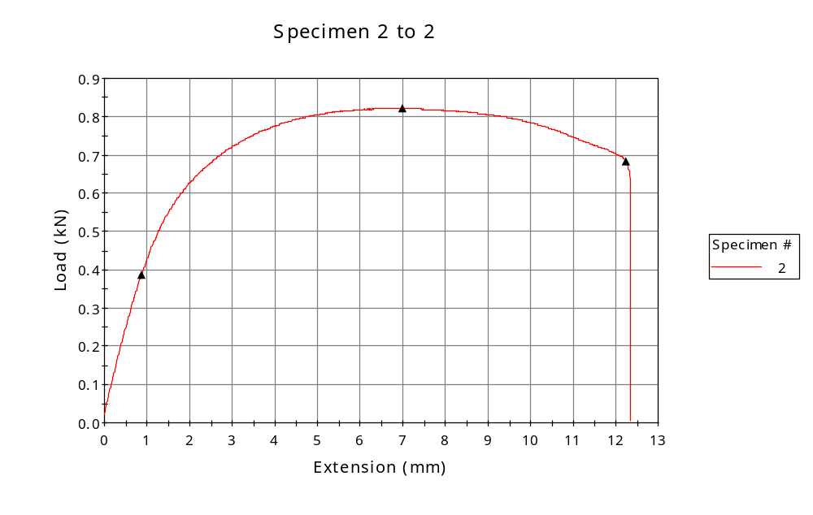
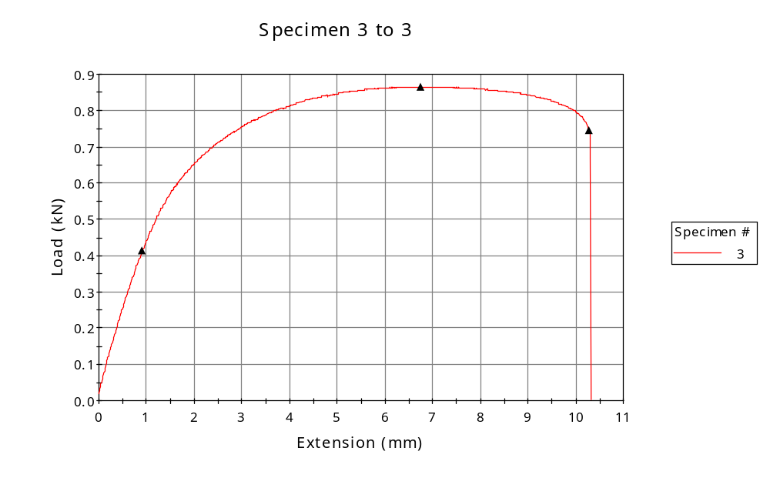
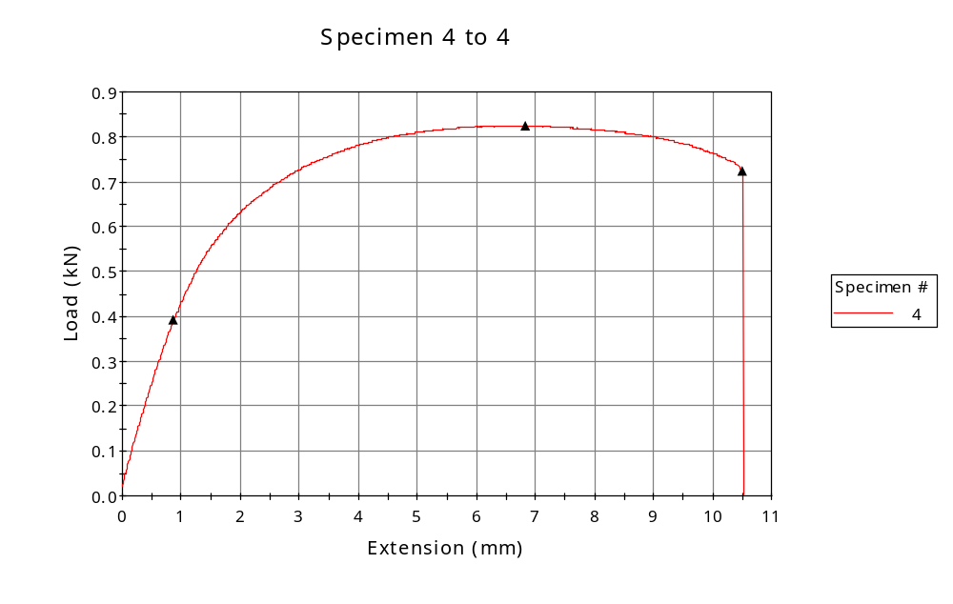
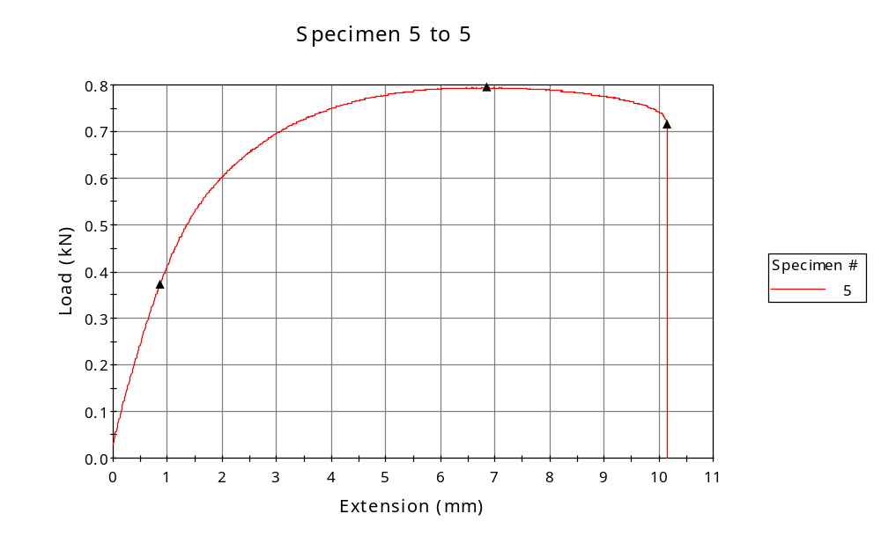

 | CP ID | Length  (mm) | Width  (mm) | Thickness  (mm) | Modulus (Automatic Young's)  (MPa)
1 | CP-SLS_YX5_01 | 25.00 | 6.13 | 3.35 | 1428
2 | CP-SLS_YX5_02 | 25.00 | 6.37 | 3.32 | 1330
3 | CP-SLS_YX5_03 | 25.00 | 6.32 | 3.46 | 1422
4 | CP-SLS_YX5_04 | 25.00 | 6.17 | 3.35 | 1381
5 | CP-SLS_YX5_05 | 25.00 | 6.13 | 3.26 | 1394
Maximum |  | 25.00 | 6.37 | 3.46 | 1428
Minimum |  | 25.00 | 6.13 | 3.26 | 1330

 | Load at Fy ( 0.2 %) - LE  (kN) | Tensao em Fy ( 0.2 %) - LE  (MPa) | Deformacao em Fy ( 0.2 %) - LE  (%) | Forca Max  (kN) | Tensao na Forca Max - LR  (MPa)
1 | 0.391 | 19 | 1.547 | 0.827 | 40
2 | 0.386 | 18 | 1.569 | 0.822 | 39
3 | 0.413 | 19 | 1.568 | 0.866 | 40
4 | 0.392 | 19 | 1.578 | 0.825 | 40
5 | 0.373 | 19 | 1.556 | 0.795 | 40
Maximum | 0.413 | 19 | 1.578 | 0.866 | 40
Minimum | 0.373 | 18 | 1.547 | 0.795 | 39

 | Deformacao na Forca Max - LR  (%) | Forca na Forca na Quebra - LQ  (kN) | Deformacao na Forca na Quebra - LQ  (%) | Final length  (mm) | Final width  (mm)
1 | 22.946 | 0.733 | 38.680 | 119.00 | 6.82
2 | 24.461 | 0.682 | 45.461 | 119.00 | 6.82
3 | 23.070 | 0.744 | 37.170 | 119.00 | 6.82
4 | 23.731 | 0.722 | 38.398 | 119.00 | 6.82
5 | 23.784 | 0.715 | 36.951 | 119.00 | 6.82
Maximum | 24.461 | 0.744 | 45.461 | 119.00 | 6.82
Minimum | 22.946 | 0.682 | 36.951 | 119.00 | 6.82

 | Alongamento
1 | 3.76
2 | 3.76
3 | 3.76
4 | 3.76
5 | 3.76
Maximum | 3.76
Minimum | 3.76

